**EXPERIMENT # 10**

**Installation of PSpice Schematics**

**Objectives:**

How to install PSpice and making circuits on it.

**Apparatus:**

1. Download PSpice
2. Install PSpice

**Theory:**

PSpice stands for **Personal (Computer) Simulation Program with Integrated Circuit Emphasis**. It is a tool to design and develop analog circuits and to simulate the behavior of a circuit. One can design a schematic diagram and develop a PCB of several layers. Using this tool, you will know how your circuit is likely to behave in real world and when you prepare PCB assembly, it is likely to follow nearby result of circuit design on PSpice simulator. Simulation result can be displayed on real axis.

**Installation Steps**

**Step 1:**

Choose the schematic editors.

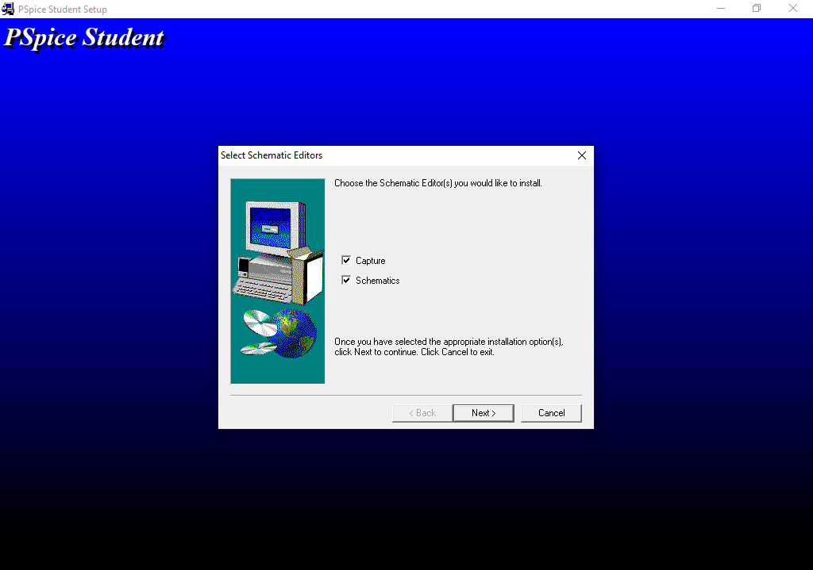

**Step 2:**

Choose the required folder for installation.

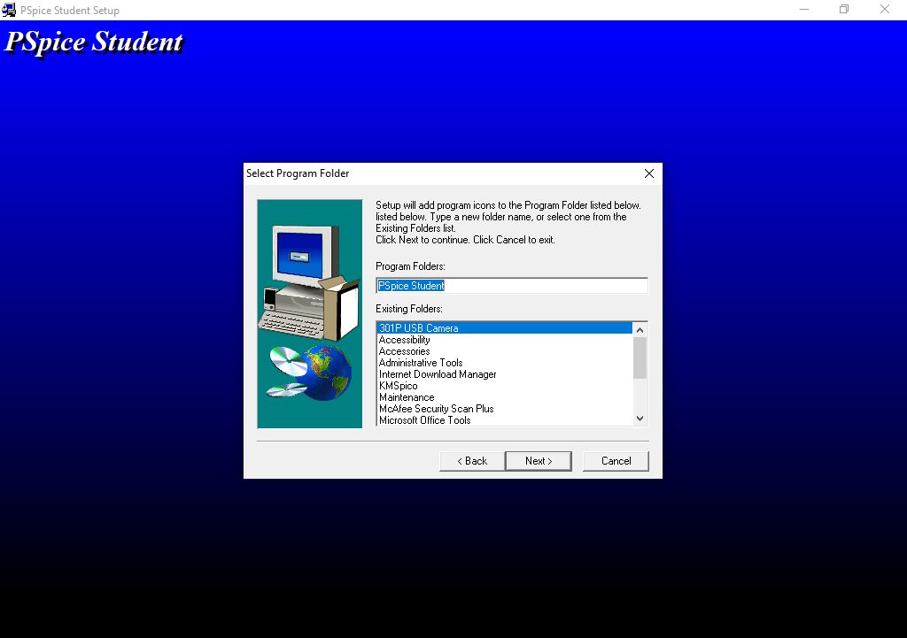

**Step 3:**

Choose the program folder from the existing folder.

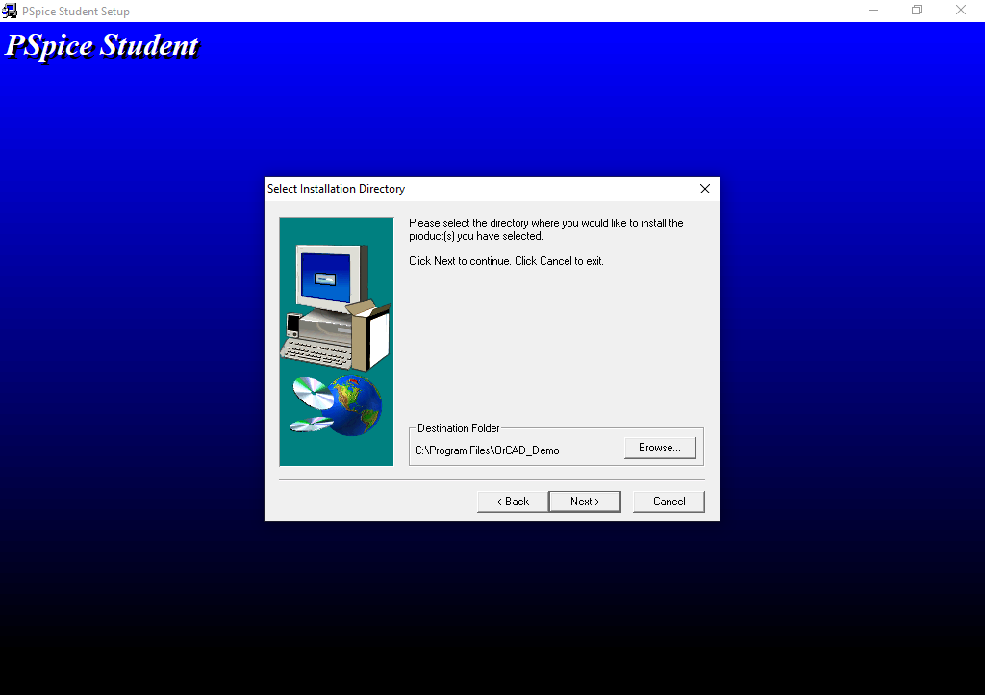

**Step 4:**

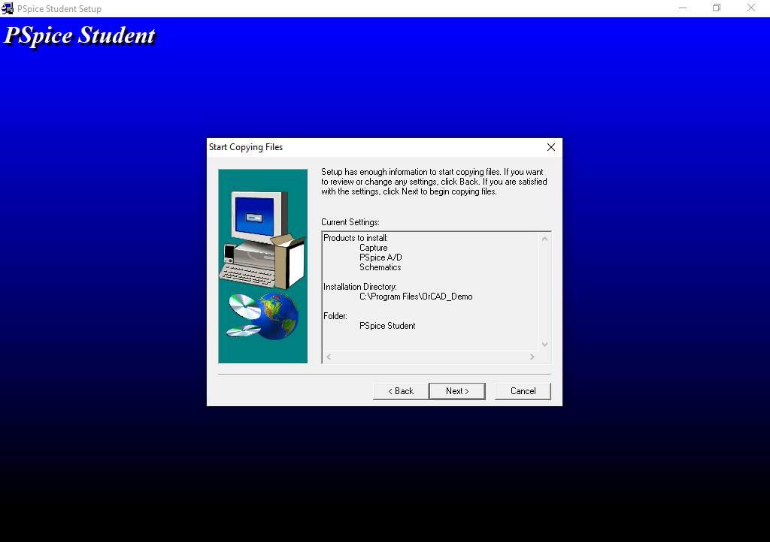Product to install and installation directory information.

**Step 5:**

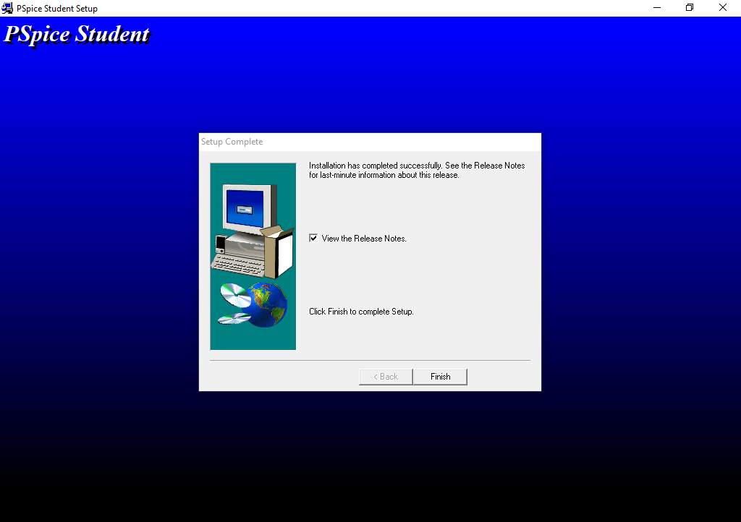Finish setup.

**Conclusion:**

Today I learn how to install PSpice.